IT Operating Manual

<Service-ID> - ITOM - ProvisionPoint - <DELIN>

|  |  |
| --- | --- |
|  |  |
|  |  |
|  |  |
|  |  |
|  |  |
|  |  |
|  |  |
| **Main IT Service Catalogue Service** | <Service Catalogue ID : X.0.0 > |
| **Related IT Service Catalogue Service(s)** | <Service Catalogue ID : X.0.0 > |
|  | <Service Catalogue ID : X.0.0 > |
|  |  |
| **Prepared by** | < Alexandu Andrei> |
| **Date** | <15.11.2019> |
| **Version** | <V 0.1> |
| **Status** | <Draft> |
|  |  |
|  |  |

Content

Administration 4

1 Introduction 4

2 Service Description 5

2.1 System Layout 5

2.2 Functional Layout 5

2.3 Design Decisions 5

3 Installing the Service 6

3.1 Installation Prerequisites 6

3.2 Installation 6

3.3 Post-Installation Processing 6

3.4 Configuration 6

3.5 Verifying the Installation 6

3.6 Uninstalling the Service 6

4 Startup and Shutdown of Service 7

4.1 Startup 7

4.2 Shutdown 7

5 Maintenance 8

5.1 Maintenance Activities 8

5.2 Frequency 8

5.3 Maintenance Windows 8

6 Back Up and Restore 9

6.1 Redundancy 9

6.2 Backup 9

6.3 Recovery 10

6.4 Data Retention/Archiving 10

7 Database Requirements 11

7.1 Database Product 11

7.2 Configuration 11

7.3 Maintenance 11

8 Error Messages and Troubleshooting 11

9 Security and Controls 12

9.1 Security and Controls Concept 12

9.2 SOX Requirements 12

10 Internal Key User / Business Application Owner 13

11 External Support 13

12 Service responsibilities / Operational Modell 13

12.1 GUS 13

12.2 GITO 13

12.3 GAD 13

12.4 Business 13

Solution Architecture Overview 14

Administration

**Version History**

|  |  |  |  |  |
| --- | --- | --- | --- | --- |
| Version | Date | Author | Change ID | Changes |
| <version> | <dd.mm.yyyy> | <author> | <USU change number stated as CID_xxxx > | <changes> |
| <version> | <dd.mm.yyyy> | <author> | <USU change number stated as CID_xxxx > | <changes> |

# Introduction

The purpose of this IT operations manual is to provide all necessary information for proper operation of the service / application.

The intended audience of the operating manual is the IT support organization (GUS / GITO).

# Service Description

**ProvisionPoint** is a solution for O365 provisioning. It can either create Modern Sites, including O365 Groups and Microsoft Teams, or Classic SharePoint Sites, including Site Collections and Sub Sites.

User Adoption of Office 365 is further improved, enabling end users to create new Sites, Groups and Teams on their own. Therefore, users can easily provision the right objects based on templates.

We in IT can easily configure these templates which define how a requested object will be created and each template can include features, structure and other functionality.

We can define who can request a Microsoft Team and implement approval processes with the requests if related demands show up.

Governance is also about the correct security settings being applied to Teams and ensuring that teams are correctly classified. In **ProvisionPoint**, administrators define how which settings are applied to a team when it is created. Further, there is the option for each team to control Privacy, Classification and Guest Access.

The ProvisionPoint application can be accessed here: <https://app.provisionpoint.com/#/request>

## System Layout

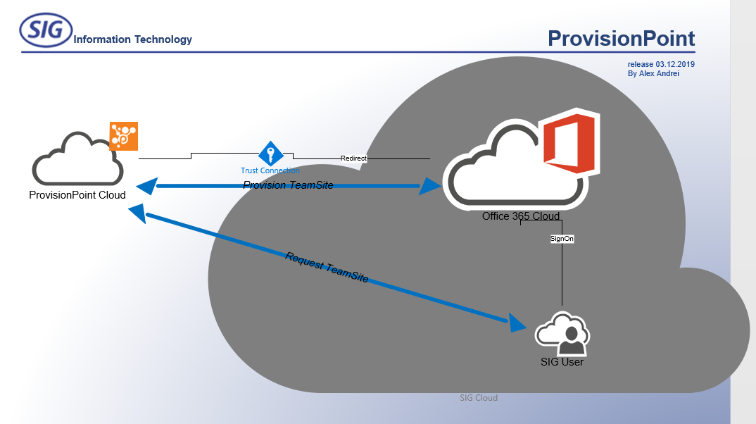

The ProvisionPoint Environment is based on a «**Trust**» connection with the **MS Cloud**.

This means that the users don’t need to connect to **ProvisionPoint**, but to our own **O365** tennant.

That connection is then redirected to **ProvisionPoint**.

The user then creates the request directly on the **ProvisionPoint** site, which in turn preprocesses the request and passes it forward to **SharePoint** **Online**.

# Installing the Service

1. Complete the signup form at:

<https://app.provisionpoint.com/signup>:

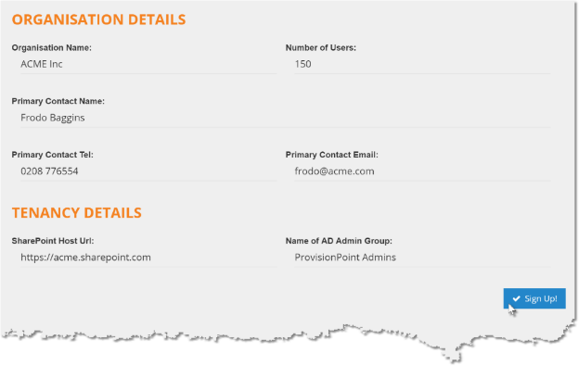

1. This will redirect to the Azure AD and the Microsoft Consent Form:

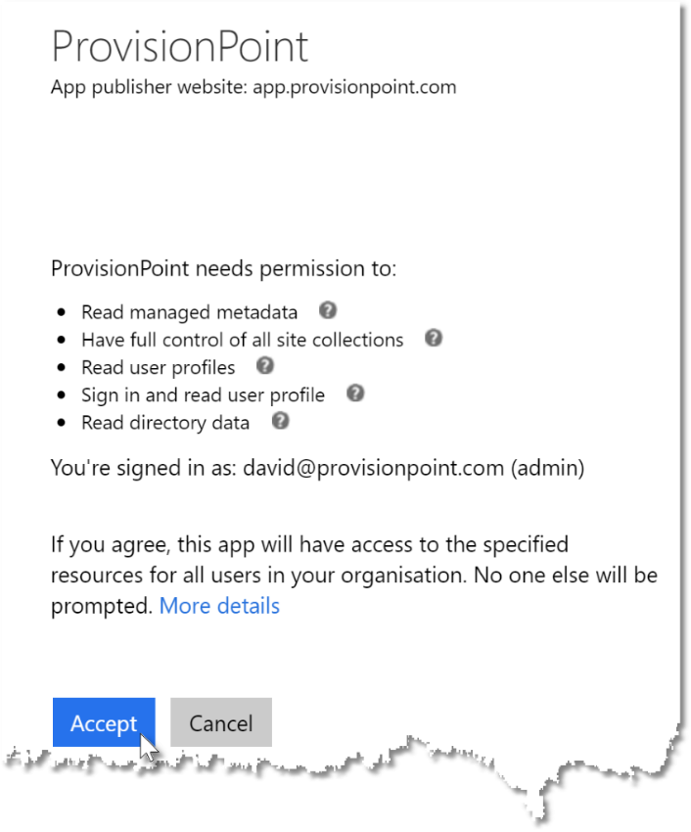

Instalation must be done by a Global Admin of the Azure AD tenant

## Uninstalling the Service

The is no uninstallation process required.

To remove the service just terminate the Trust Relationship:

1. Logon as Administrator to the Azure Portal
2. Search for Enterprise applications
3. Select ProvisionPoint
4. 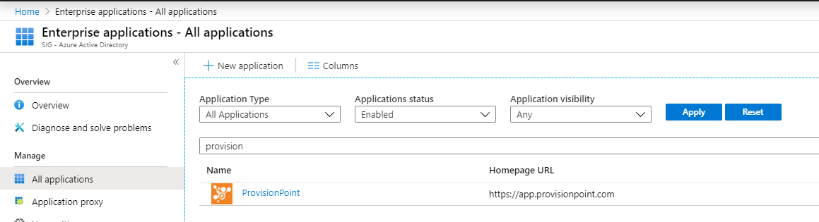
5. 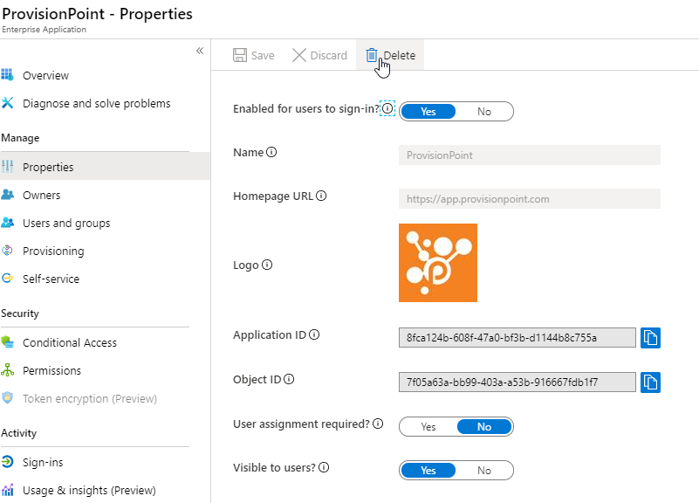
6. Disable sig-in or Delete altogether.

# Startup and Shutdown of Service

Being a Cloud service, it’s considered «Always ON»

# Maintenance

## Maintenance Activities

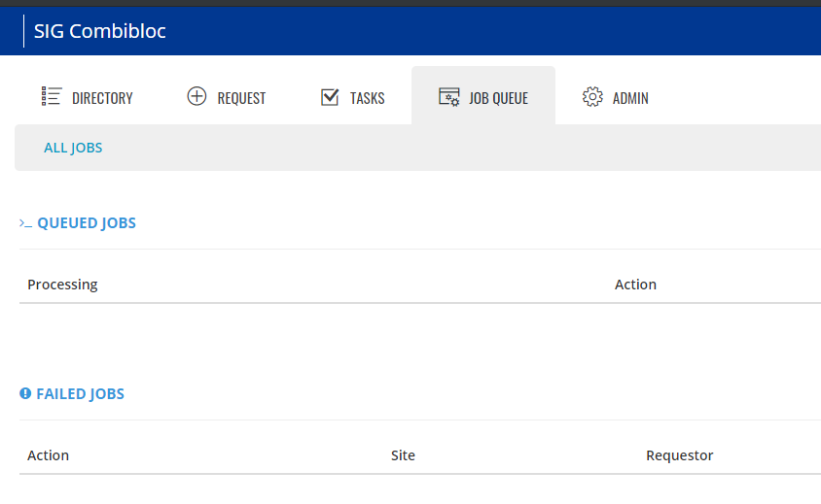

Monitor Job Queue and restart failed jobs, if any.

# Back Up and Restore

The SIG standard procedures are defined in the “ITGC Document for IT Backup and Restore”

## Redundancy

Not applicable

## Backup

Not applicable

## Recovery

Not applicable

## Data Retention/Archiving

Not applicable

# Database Requirements

Not applicable

# Error Messages and Troubleshooting

**In case of a separate Troubleshooting Guide should be used, please refer to it.**

<Service-ID> - Troubleshooting Guide - <short name IT-Service> - <SiteCode>

In this section, explain the common error messages and responses. Document any cases in which malfunctions occur and provide appropriate handling instructions.

# Security and Controls

## Security and Controls Concept

App Admistrators can manage ProvisionPoint security. This comes in 3 levels:

• App Managers: primary administrators of ProvisionPoint, can manage all parts of the service.

• Service Definition Managers: can create new Service Definitions.

• Licensed Users: refers to everyone who needs to have access to ProvisionPoint (Access the directory, see site information and/or request a new site – in this case all O365 users).

The AD groups that handle the APP access were created according to the security roles in the tool and are situated in:

OU=O365_AzureAD ,OU=Administrative Groups, OU=SIG Global Resources

The 2 groups created are:

**SR-SAAS-O365-SPO-ProvisionPoint-SDAdmin** - Service Definition Manager role

**SR-SAAS-O365-SPO-ProvisionPoint-Admin** - App Manager role

The creation of O365 Group based services can be performed using the app permissions or a named service account.

If using app permissions, it's good to provide a service account too as certain actions cannot be performed using app permissions such as setting a Group/Team logo.

The password entered here is not stored in the ProvisionPoint database, but is kept secure in an Azure KeyVault.

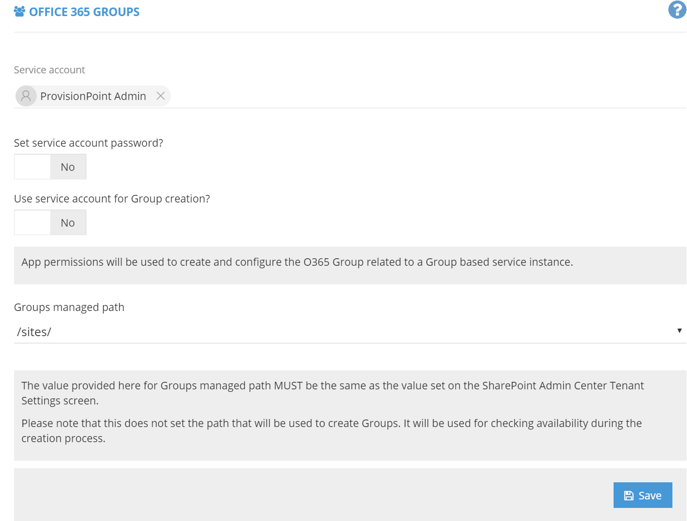**Admin – Setting – App Settings:**

As ProvisionPoint runs as an Azure Active Directory App, the only setup needed to integrate ProvisionPoint in our tenant is adding the API key and granting the consent, in addition to creating a service account able to create O365 Groups.

The ProvisionPoint Admin service account is located in:

CN=ProvisionPoint Admin, OU=Extra Accounts, OU=Users, OU=Local Resources, OU=DELIN,

## SOX Requirements

List any SOx required documentation or SOx checks related to the security and controls procedures if applicable.

# Internal Key User / Business Application Owner

Not applicable

# External Support

|  |  |
| --- | --- |
| **Technical Support** | **Commercial Support** |
| Peter Baddeley  Product Manager  ProvisionPoint  +44 (0)7812 139860  [peter@provisionpoint.com](mailto:peter@provisionpoint.com)  [www.provisionpoint.com](http://www.provisionpoint.com/) | Seb Matthews  Commercial Director  ProvisionPoint  UK: +44 (0)7765 090308  [seb@provisionpoint.com](mailto:seb@provisionpoint.com) [www.provisionpoint.com](http://www.provisionpoint.com) |

# Service responsibilities / Operational Model

In this chapter list the persons of function (department) and their responsibilities within the service.

## I&O - Alexandru Andrei -> Service Owner - DWP Team -> 2nd Level Support - Service Desks -> 1st Level Support

## GAD

## Business

Solution Architecture Overview

Include a graphical overview of the solution architecture.